

**TASK 4**

**DIGITAL SIGNAL PROCESSING**



**Submitted by: Submitted to:**

Anupam Kshetri Prof. Vivien Glönkler

33471



**TASK 4**

The task was done to calculate the G(s) and state G(s) including the computation of the bilinear transformation of a first-order filter using RC-high pass as a filter.

**QUESTIONS**

In a book publication office, there is a fire alarm systems that detect the occurrence of an event that may result to a fire. It receives a signal from a fire sensor which has a RC High Pass Filter. It detects the room temperature and only sends the signal of the frequency higher than the certain temperature that is likely to cause fire and the system then activates the alarms and sprinklers in the office.

1. Use the appropriate values for resistance and capacitance of RC High pass filter to calculate G(s) and state G(s) in the task.
2. Plot all the response including magnitude, phase and analog frequency.
3. Plot the 3D graphics of poles and zeroes of the RC high pass filter without using fvtool.

**HINTS**

1. Use the value of Resistance (R) = 100 and Capacitance (C) = 0.000008 to find out the value of Time Constant (Tau).
2. Use the formula to find the analog frequency response.
3. Find the bilinear transformation without using prewarping.

**SAMPLE CODE**

R = 100

C = 0.000008

Tau = R * C % Time Constant

fga = 1 / (2 *pi * Tau); % fga = 1/2*pi*R*C analog cut off frequency

fs = 600; %Sampling frequency

Ts = 1/fs;

fa = 0: .01: (fs/2);

z1 = 1i * 2 * pi * fa;

Gs = Tau * z1./(1+z1*Tau)

Gs_db = 20 * log10(abs(Gs)); %analog frequency response in db

[b, a] = bilinear([1], [Tau 1], fs); % bilinear transform

[z,p, k] = tf2zpk(b,a);

%%

figure("Name","magnitude and phase response")

subplot(2, 1, 1);

hold on;

freqz(b, a, 1024, fs); %digital frequency response

plot(fa, Gs_db, 'r'); %analog frequency response

legend('Digital Frequency Response', 'Analog Frequency Response');

hold off;

%%

%3d plotting

x = -1:0.02:1 ; % x axis

y = -1:0.02:1 ; % y axis

[X,Y] = meshgrid(x,y) ;

s1 = X + j.*Y ;

H1 = (s1 - z).*(s1 - z)./((s1-p).*(s1-p)) ; % function

figure("Name","3-D") ;

s3 = surf(X,Y,abs(H1),'FaceAlpha',.75); % 3D graph zeros and poles

camlight('headlight') ;

**GRAPHS**

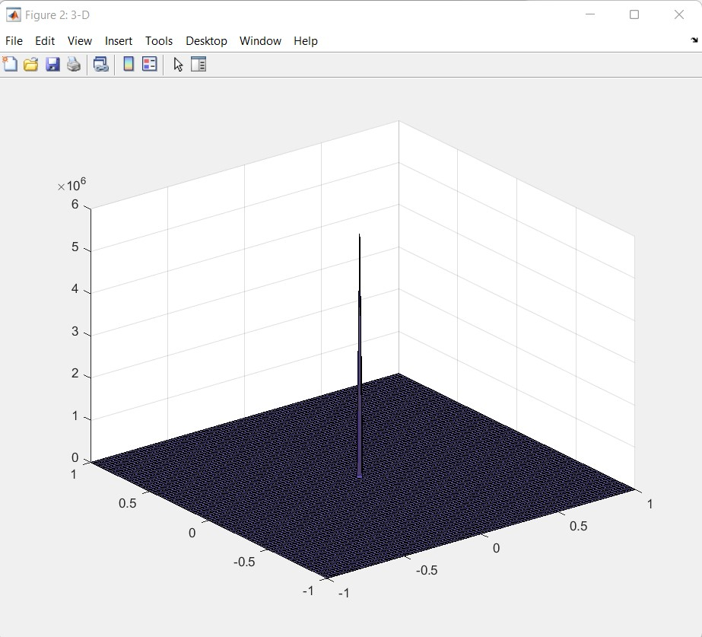

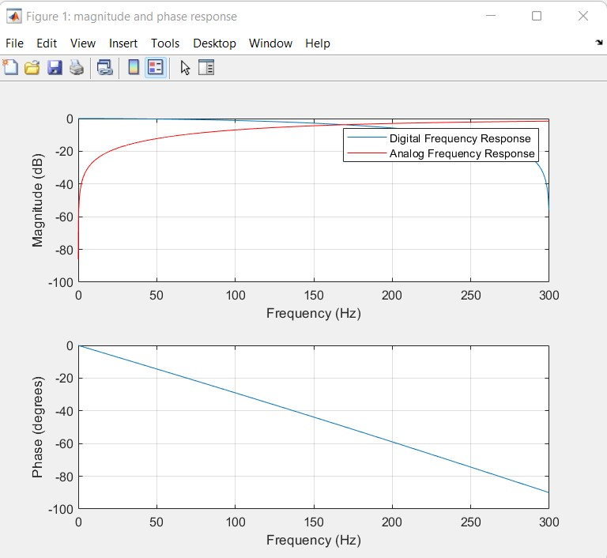

The graph from the sample solution.

**Reference:**

[1][Implement first-order filter - Simulink - MathWorks Deutschland](https://de.mathworks.com/help/physmod/sps/powersys/ref/firstorderfilter.html)

[2][Bilinear transformation method for analog-to-digital filter conversion - MATLAB bilinear - MathWorks Deutschland](https://de.mathworks.com/help/signal/ref/bilinear.html)